* Put sim card and start device
* By default device has:
  + 10.0.0.53
  + 255.255.255.0
* eBuddy is a soft to change ips
* after each config changes, reboot
* now all the settings
* eth interface settings

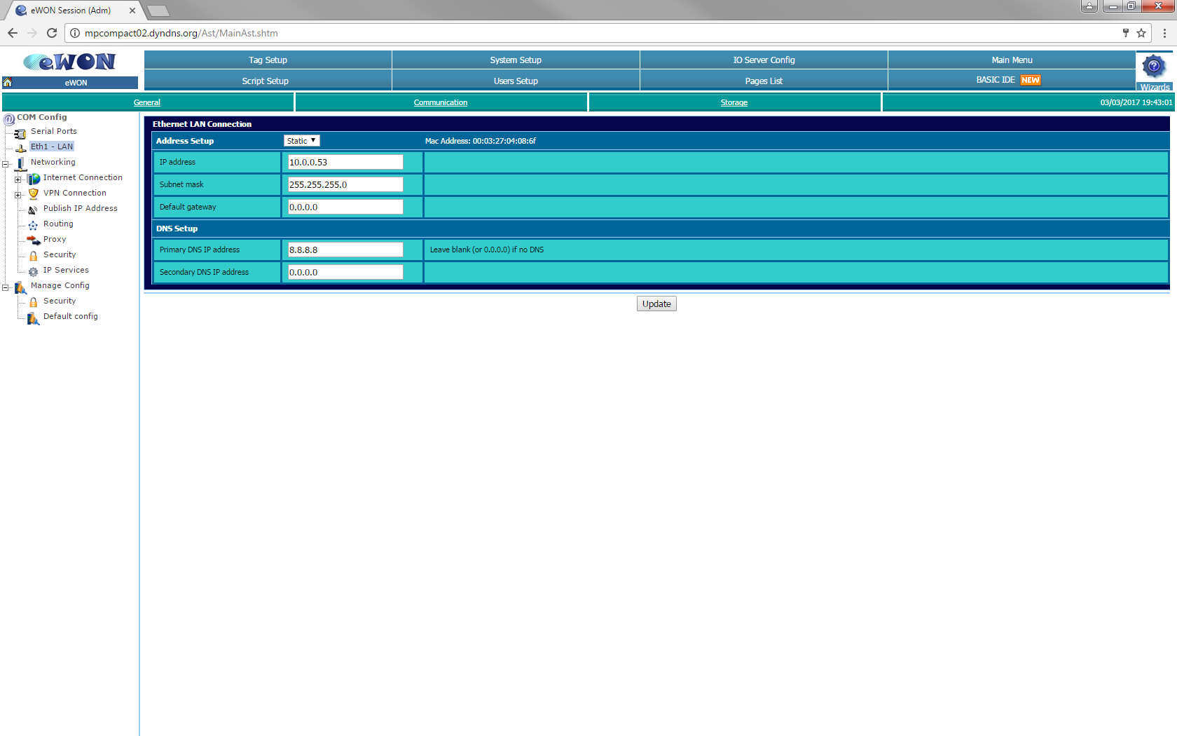

* internet connection settings (first time click connect and the GSM led should go green
* a problem with sim card will show no led

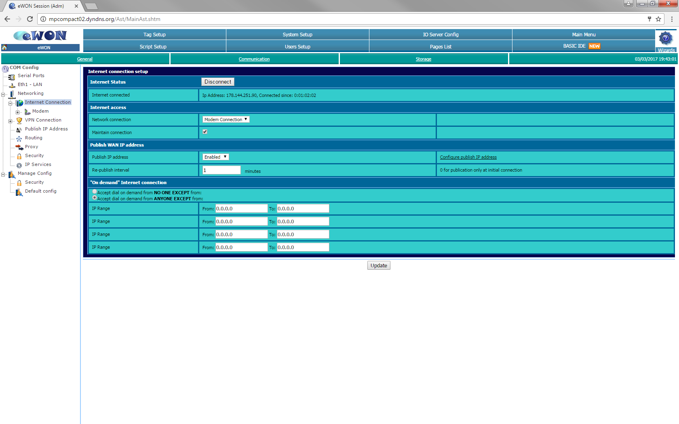

* interface settings

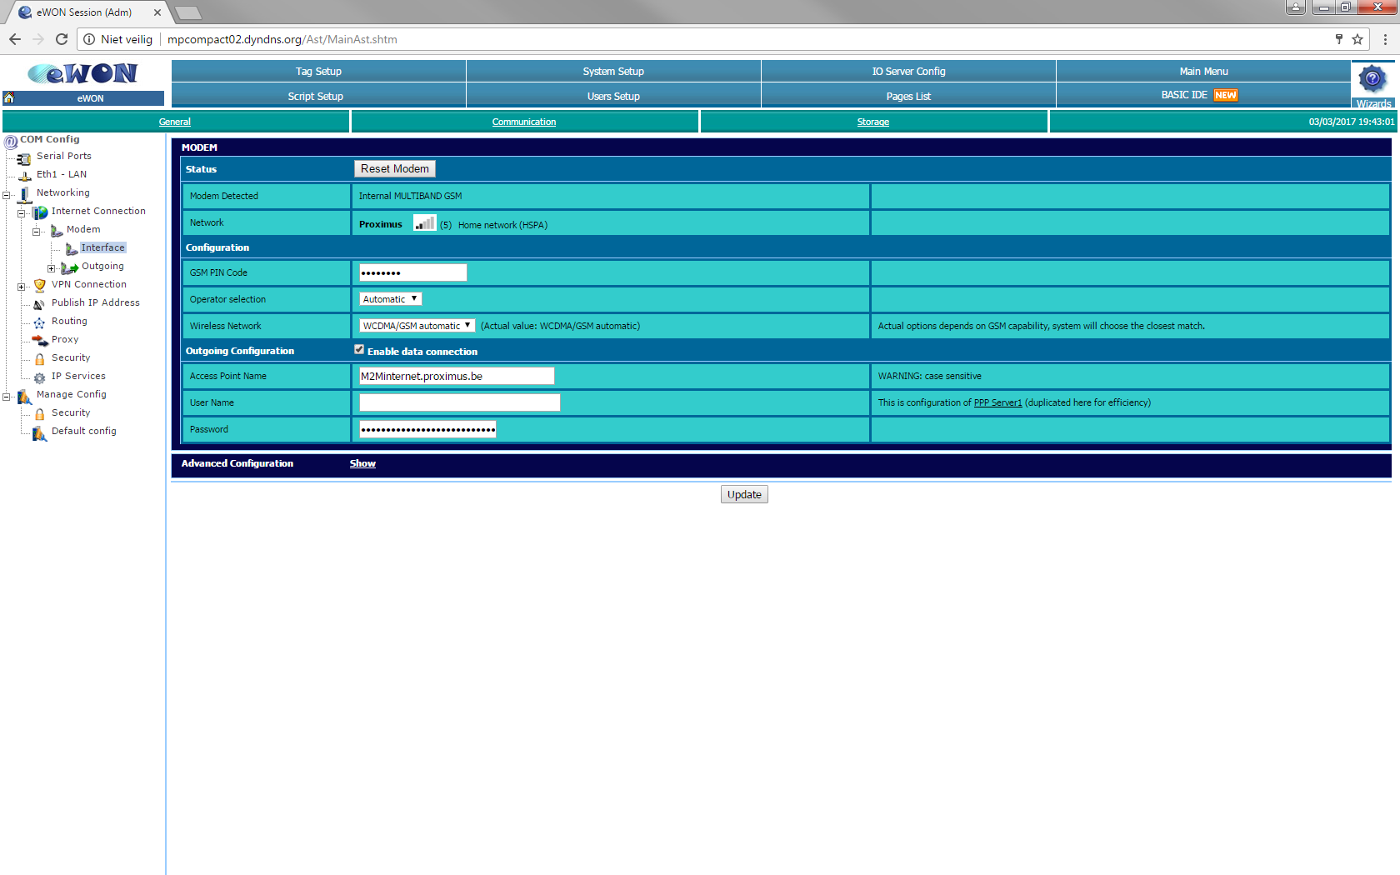

* check the settings global outgoing are as bellow

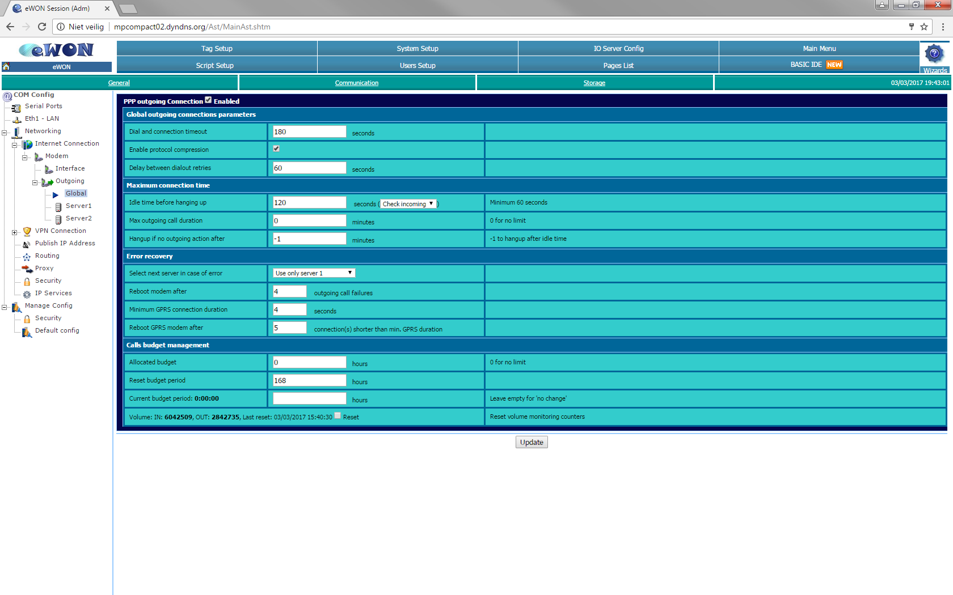

* dyndns (Phillipe.mol@..., mpbephmo)

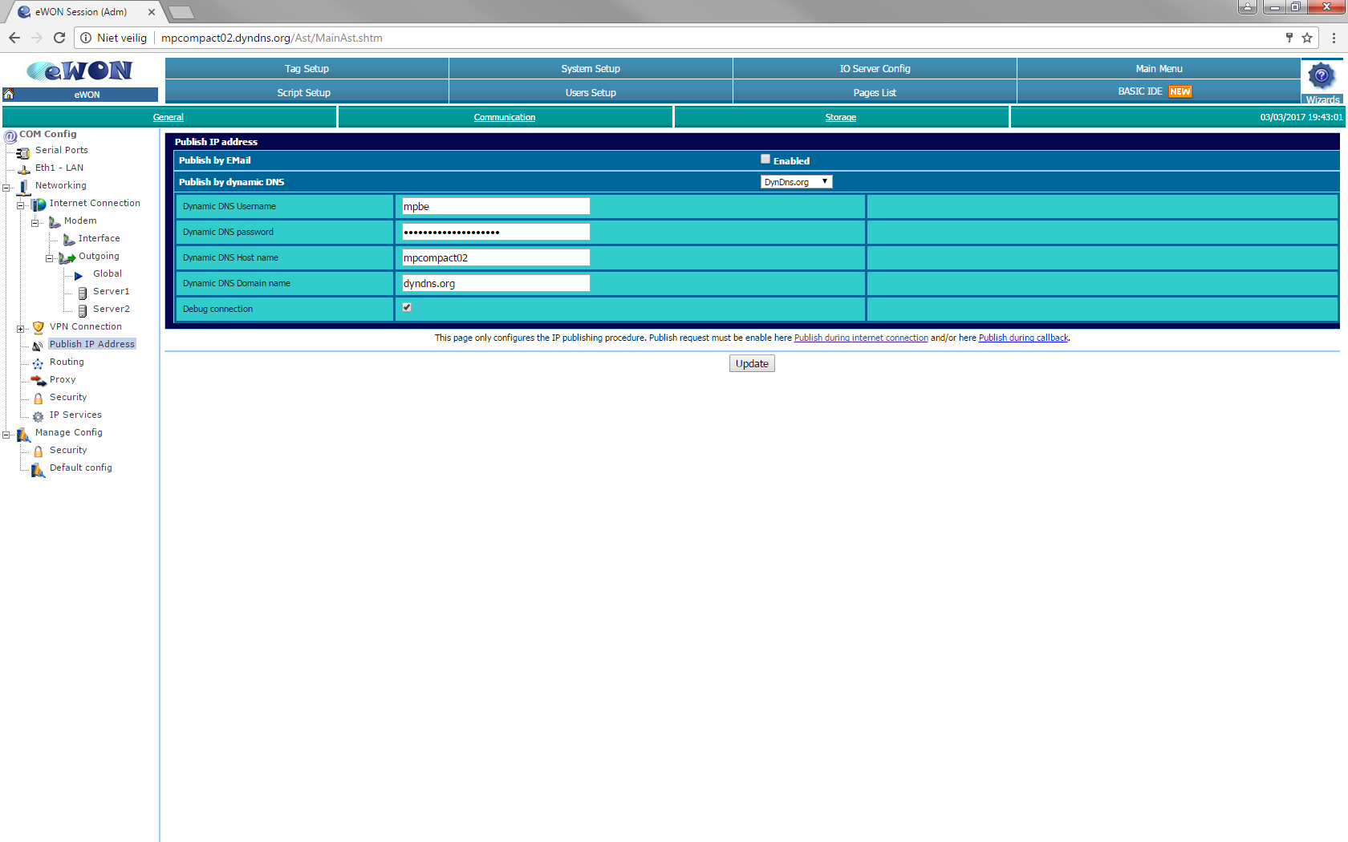

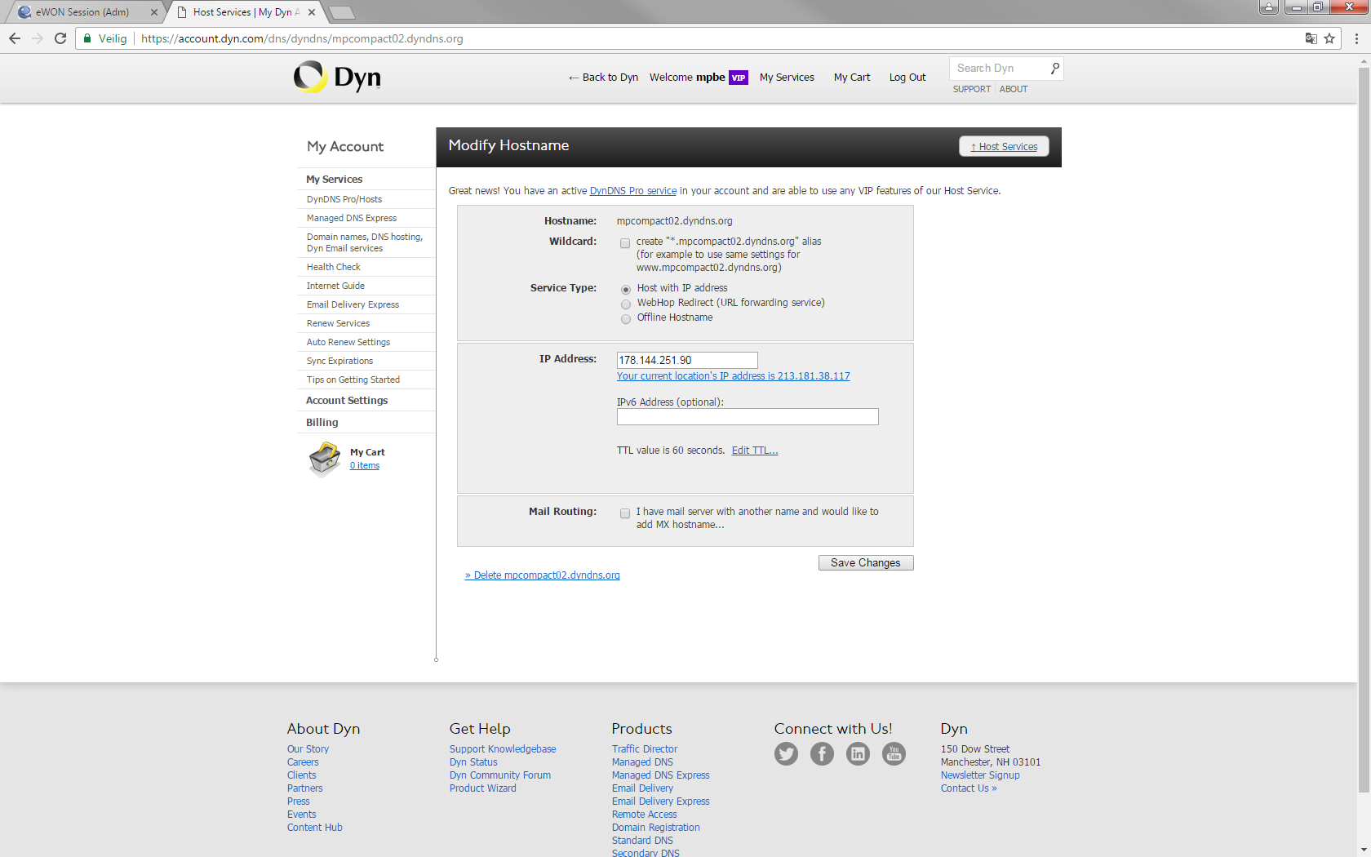

* rooting setting

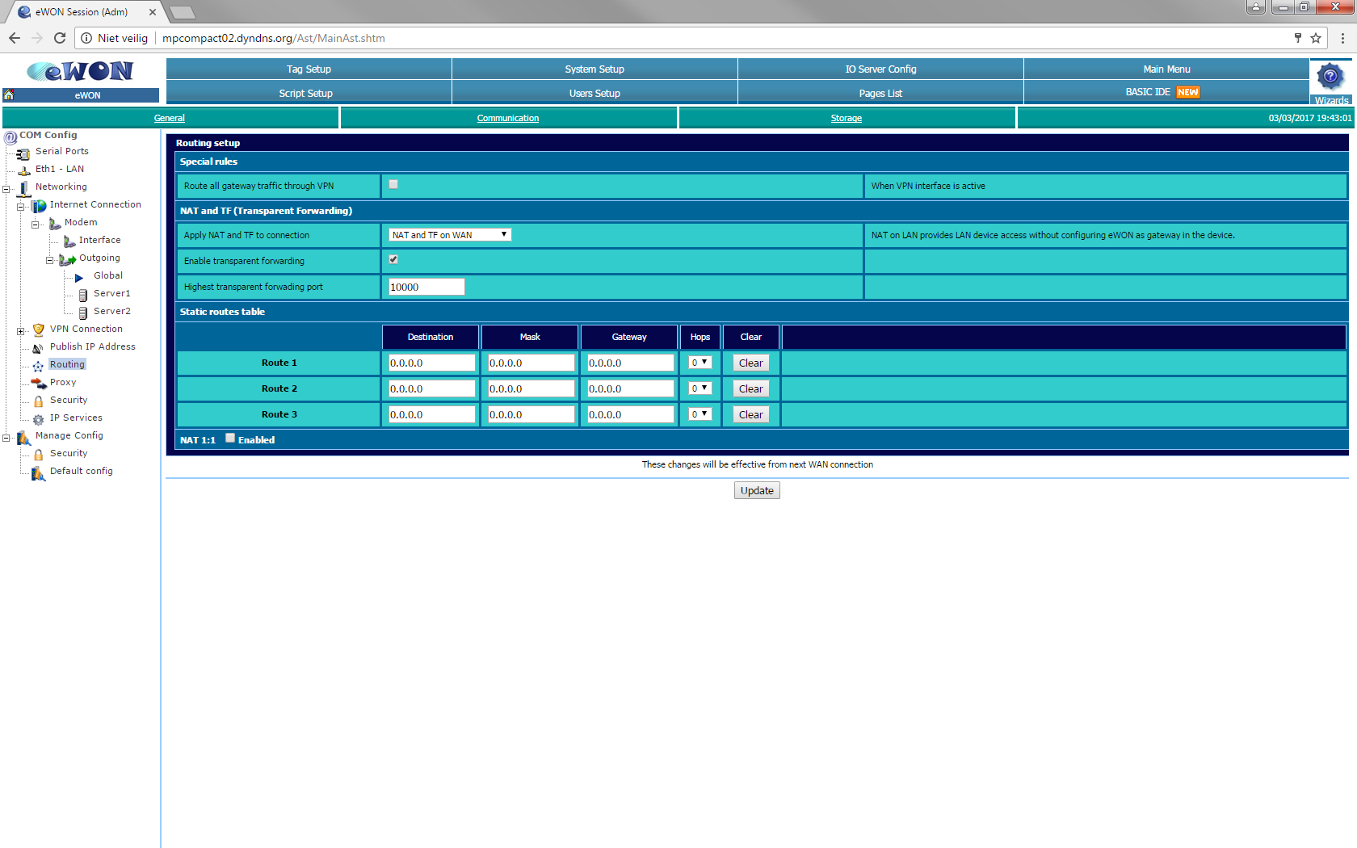

* security setting

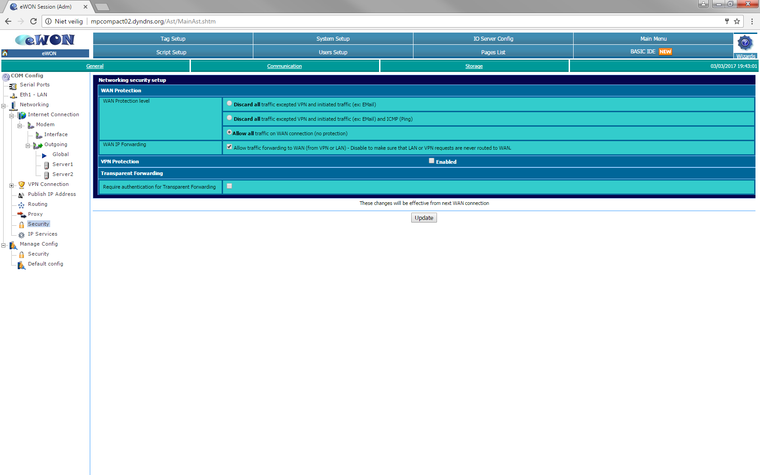

* pc settings
  + ip 10.0.0.54
  + sub 255.255.255.0
  + gate 10.0.0.53
  + dns 8.8.8.8